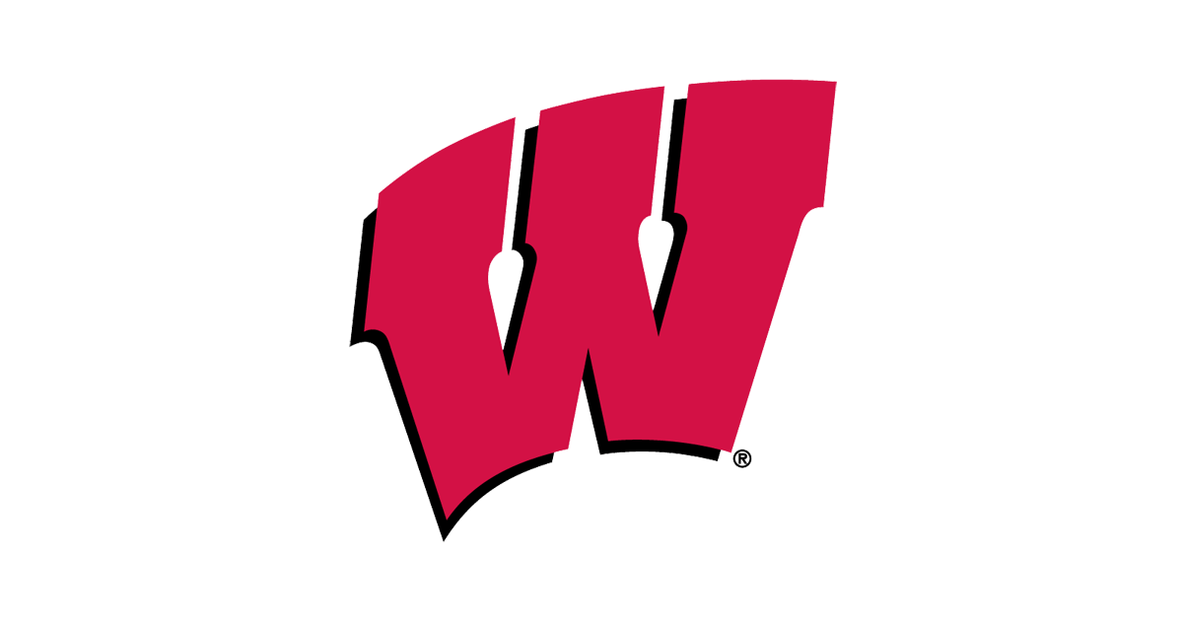
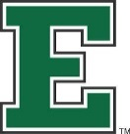

Monday, November 13th – Friday, November 17th

Monday: | College Spirit Day - Wear your college spirit wear  #MoneyMonday  - Learn about Financial Aid and Scholarship options during all 4 lunches outside the cafeteria
Tuesday: | Cap and Gown Day – seniors and teachers wear your cap and gown in support of graduation  #PledgeToProsper  - Seniors!! Sign the banner located outside of the cafeteria and make the pledge during all lunches
Wednesday: | Support your Sport- Show you’re a true sports fanatic! Go all out for your favorite college sports team.  #LunchandLearn  - Senior and juniors sign up to learn about the college application process. In the College and Career Center during all lunches
Thursday: | Greek and Student Organization Day– Teachers and Students wear your Greek and student organization gear  #StepIntoSuccess  - Local Greek fraternity/Sorority Step team
Friday: | College Door Décor Judging – Help teachers decorate their classroom door advertising the college of their/your choice.
 | #Wildcat Nation
- Hear from WHS Alumni and ask questions about their college going experience

